## ***HANDSON - 1***

## **Objective:**

Familiar with Git commands like git init, git status, git add, git commit, git push, and git pull.

**Setup your machine with Git Configuration**

1. First, I checked if Git client is installed properly

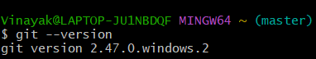

1. Then I configured user ID and email ID,

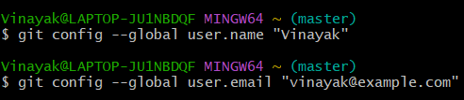

1. I checked if the configuration is properly set.



**Integrate notepad++.exe to Git and make it a default editor**

1. Verified Notepad ++ from gitbash



1. Verified if notepad++ is the default editor



1. Added welcome file

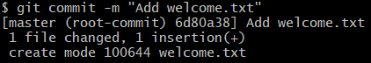

**Add a file to source code repository**

Performed the required steps and now the welcome.txt is present in GitDemo.

